1. Referring to the following flowchart, write a C++ function that implements Bisection Method.

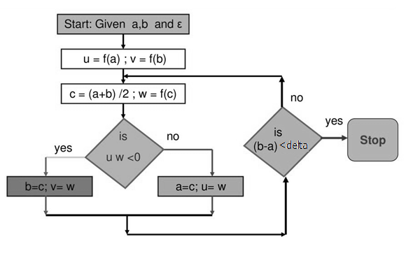

1. Referring to the following flowchart, write a C++ function that implements False Position Method.

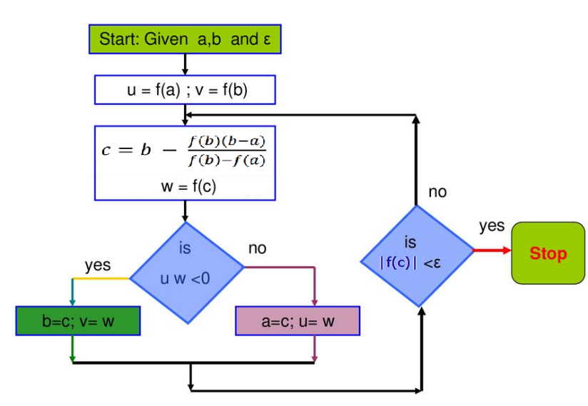

1. To test your functions use one chosen function from exercises available on page 61 on textbook. You should choose the function as follows:
   1. If (your University ID number mod 4) = 0 then your test function is exercise 7
   2. If (your University ID number mod 4) = 1 then your test function is exercise 6
   3. If (your University ID number mod 4) = 2 then your test function is exercise 5
   4. If (your University ID number mod 4) = 3 then your test function is exercise 4
2. Finally, use implemented functions to write a menu driven program that asks the user to choose one method of the above two methods and then test the method using the assigned function in part 3.

Note: Assume that both delta and epsilon are equal to $5×{10}^{-9}$, and Max = 50